**Name :**

**Hafsa Waseem**

**Roll no:**

**SU92-BSSEM-S24-014**

**Subject :**

**DSA (Lab)**

**Section :**

**3A**

**Submitted to:**

**Sir Rasikh**

**Task no 9:**

**Implement functions to insert node at first, last, Nth location, and centre of a circular linked list. And display in order and display in reverse order.**

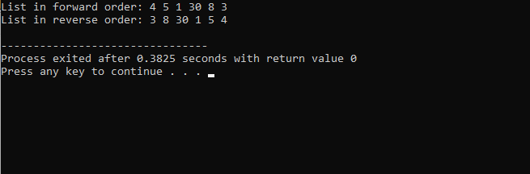

In this code we made a circularlinkedlist with operations to insert nodes at the first, last, Nth position, and center. It also allows displaying the list in both forward and reverse orders. The list is circular, where the last node points to the head. The main function demonstrates inserting nodes and displaying the list in both directions.